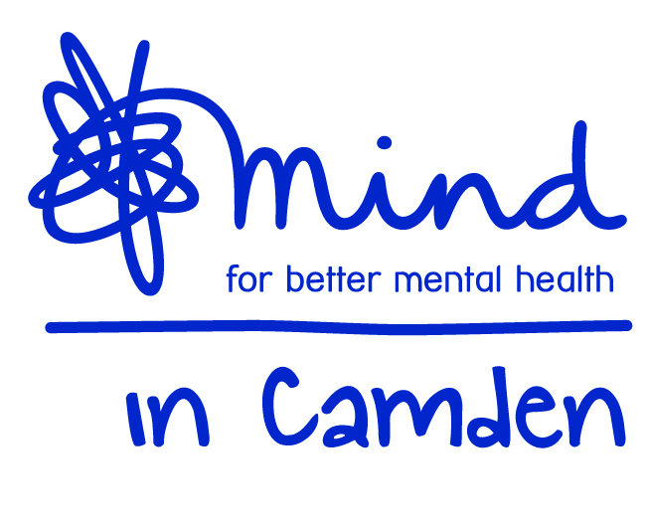

Mind in Camden

Cultural Advocacy Community Development Worker

(PT 21 hours per week) NJC SCP 22-25 starting at £14,891 p.a. including ILW

Job Description

Job title: Cultural Advocacy Community Development Worker
Accountable to: Cultural Advocacy Project Manager
Responsible for: No staff but may be required to provide supervision and support for volunteers
Grade: NJC SCP 22-25 starting at SCP 22
Hours 21 per week
Duration: The contract with the Local Authority runs for initially for three years from October 2017, it may be extended by up to two years or be subject to change during the life of the contract.

Aim of the Job:
The overall aim is to provide the community element to a project that will create new ways of co-producing services and approaches with BME communities that address mental health issues, through ground up and innovative community approaches using flexible co-production development processes with communities in three overlapping phases:

Phase 1: Planning and co-production
Engaging community Mental Health Champions and key community organisations to identify key issues to address around mental health in the communities and to identify specific work around three themes:
- Co-produced preventative work
- Community capacity building
- Increasing access to other preventative services in the Camden Resilience Network
This will identify both what we will do to make a difference for individuals and culturally specific outcome measures.

Phase 2: Implementation
The project will engage in developing and co-producing mental health wellbeing and recovery services to reduce reliance on statutory services through providing and enabling the provision of Community Mental Health Peer Support Groups, Individual Support, Community Workshops, Community Mental Health Volunteers and Hospital based services and a 1 day per week help line to support community organisations, staff and volunteers.

Phase 3: Sustainability
This will look at the resources and support needed to make developments sustainable, include training and help in fundraising, training the trainers and ongoing peer support arrangements for those delivering services – effectively creating a network of support and generating resources for the work to be ongoing after this project ends.

In the first year priority groups will be Bangladeshi and Black communities, with work developing with other communities over subsequent years.
.
a) Community Capacity Building
- With the Project Manager and Voluntary Action Camden Community Liaison Worker engage in planning and delivering an active community outreach programme to engage BME community groups and individuals in the project as hosts and providers of services
- Develop, organise and deliver training to community organisations and partners on mental health related topics and skills and provide ongoing coaching and telephone support as required to support the successful implementation of activities.
- Develop, organise and deliver training in developing and running peer support groups, with ongoing support for group facilitators through convening facilitator network meetings
- Organise and deliver community workshops to raise awareness and train service users and staff, co-produced with BME individuals and organisations
- Deliver an initiative to enable BME community groups to recruit, train and develop dedicated mental health specific volunteers, and support dedicated mental health volunteers in host organisations
- Facilitate sessions with statutory community and BME organisations to enable better access for community members to existing services
- Keep detailed records of the work and it’s outcomes and ensure all groups and workshops are monitored and evaluated, to securely store data on a specified database.
- Produce reports on the work as required by your manager
- As far as is practicable, ensure that all work is co-delivered with local BME groups and individuals – providing infrastructure support (e.g. training the trainers, coaching and mentoring) where this is required)
- Provide an effective link to appropriate preventative and other statutory and voluntary mental health services for BME community groups and individuals, and identify ways of supporting BME service users to engage, particularly in peer mentoring initiatives run by other organisations.

b) Co produced preventative work
- Directly facilitating peer support groups to help with their development
- With the Cultural Advocacy Link Worker undertake a limited caseload of individual link work with people in hospital who are being discharged into the community
- Where appropriate in exceptional cases, and as agreed with the line manager, provide one to one support or link work in the community
- Participate in a rota of staff and volunteers to effectively pilot a helpline service providing advice and support to community volunteers and group facilitators

c) Sustainability:
1. Deliver other training, coaching and facilitation which will reduce dependency on the project and therefore help sustainability
2. Stay in contact with groups and people trained in order to evaluate longer term impact

d) General Duties:
- Work within the context of the wider Mind in Camden organisation and participate in internal and external meetings as required.
- Work alongside partner staff as an integrated team and participate in related internal and external meetings as required by your manager.
- Work to Mind in Camden policies, procedures and guidance.
- Be accountable for all aspects of your work to your manager through supervision.
- Undergo training and qualification as is consistent with the satisfactory performance in the post.
- Perform other duties as reasonably required by your manager.

All staff are expected to:
  - Recognise changes in circumstances promptly and adjust plans and activities accordingly.
  - Find practical ways to overcome barriers.
  - Present information clearly, concisely, accurately and in ways that promote understanding.
  - Assist in creating a sense of common purpose.
  - Make best use of available resources and proactively seek new sources of support when necessary.
  - Act within the limits of their own authority.
  - Be vigilant for potential risks and hazards.
  - Take pride in delivering high quality work.
  - Take personal responsibility for making things happen.
  - Take personal responsibility for effectively communicating with service users, members of their work team, managers and other work groups.
  - Consult with their work group about matters which directly affect their work.
  - Deal sensitively and effectively with service user or stakeholder complaints.

Main Conditions of Service:
- The salary is linked to, but not bound by, the NJC scale; this post is graded at SCP 22-25 starting £14,891 p.a. including Inner London Weighting for 21 hours per week and rising by annual increment to SCP 25.
- Mind in Camden has an auto-enrolled pension scheme into which it currently pays 5% of salary. From 2019 you will be required to contribute an additional 3% into the scheme.
- The hours of work per week are 21 that will ordinarily be worked between 9.30am – 5.30pm with a one hour (unpaid) lunch break. Evening, weekend and bank holiday work will be required on occasion.
- Annual leave entitlement is initially 27 days plus public holidays (pro-rata for part-time staff).
- All Mind in Camden job descriptions may be subject to periodic review.
- The post holder will work across multiple sites in Camden.

Mind in Camden

Cultural Advocacy Community Development Worker

Person Specification

All areas in the person specification are essential unless stated otherwise

Qualifications
1. None specifically required but evidence of mental health related learning essential

Knowledge
- In-depth understanding of mental health from a range of perspectives, with particular emphasis on non-medical and culture specific understandings of mental health.
- Awareness of current issues in policy and practice in mental health.
- A thorough understanding of co-production, person centred and recovery principles.
- A thorough understanding of the principles of peer support
- Understanding of anti-discriminatory practice with particular emphasis on how it applies to mental health work with people from black and ethnic minorities
- A working knowledge of safeguarding considerations
- An excellent understanding of the principles of good partnership working.
- A working knowledge of monitoring and evaluation methods, and measuring outcomes
- Understanding of confidentiality and data protection principles.
- A strong understanding of community development and promotion, including use of web and social media.

Experience of:
- Working directly with service users.
- Working in partnership with external agencies to provide services.
- Marketing and promoting services.
- A minimum of 2 years’ experience of working in mental health services.
- Delivering training and facilitating groups
- Working with networks and communities
- Working with members of specific BME communities

Skills & Abilities
- Ability to provide high quality support to service users.
- Ability to contribute to creating and inspiring a network towards a common purpose.
- Ability to implement our ethos and use personal lived experience of mental health appropriately in training, peer and individual support
- Have strong communication and interpersonal skills.
- Ability to analyse problems and make decisions.
- Ability to gather and use information/data.
- Ability to produce written materials to a high standard
- Ability to deliver presentations, training and workshops to a variety of stakeholders.
- Be highly organised with excellent time management skills.
- Have intermediate or above computer skills with ability to use database programmes.
- Ability to work independently and to utilise support effectively.

Commitment to:
- Taking personal responsibility for making things happen.
- Working flexibly and cooperatively.
- Strengths-based recovery approach to client work and person centred practice.
- Community empowerment and enablement
- Implementation of equal opportunities through anti-discriminatory practice.
- Confidentiality.
- High levels of accountability for your work to your manager.

