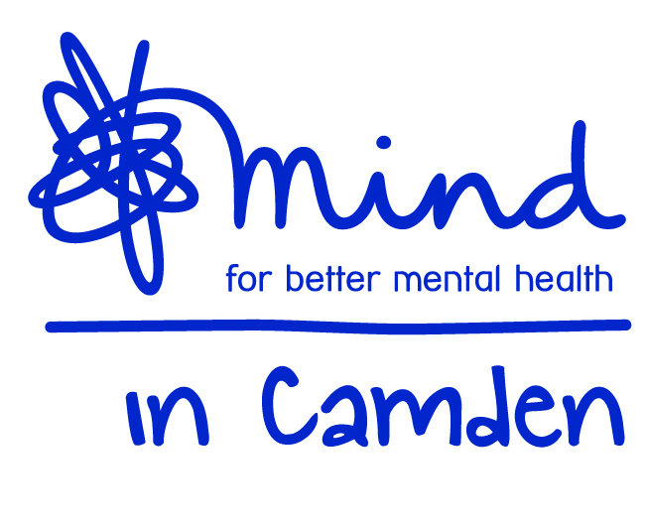

Mind in Camden

Cultural Advocacy Project Manager

(FT 35 hours per week) NJC SCP 29-31 starting at £30,108 including ILW

Job Description

Job title: Cultural Advocacy Project Manager
Accountable to: Operations Director
Responsible for: Staff and volunteers providing the service currently including a Cultural Advocacy Community Worker (21 hrs per week) and a Cultural Advocacy Link Worker (21 hrs per week)
Grade: NJC SCP 29-31 starting at SCP 29
Hours: 35 per week
Duration: The contract with the Local Authority runs for initially for three years from October 2017, it may be extended by up to two years or be subject to change during the life of the contract.

Aim of the Job:
The overall aim is to manage the project in creating new ways of co-producing services and approaches with BME communities that address mental health issues, through ground up and innovative community approaches using flexible co-production development processes with communities in three overlapping phases:

Phase 1: Planning and co-production
Engaging community Mental Health Champions and key community organisations to identify key issues to address around mental health in the communities and to identify specific work around three themes:
- Co-produced preventative work
- Community capacity building
- Increasing access to other preventative services in the Camden Resilience Network
This will identify both what we will do to make a difference for individuals and culturally specific outcome measures.

Phase 2: Implementation
The project will engage in developing and co-producing mental health wellbeing and recovery services to reduce reliance on statutory services through providing and enabling the provision of Community Mental Health Peer Support Groups, Individual Support, Community Workshops, Community Mental Health Volunteers and Hospital based services and a 1 day per week help line to support community organisations, staff and volunteers.

Phase 3: Sustainability
This will look at the resources and support needed to make developments sustainable, include training and help in fundraising, training the trainers and ongoing peer support arrangements for those delivering services – effectively creating a network of support and generating resources for the work to be ongoing after this project ends.

In the first year priority groups will be Bangladeshi and Black communities, with work developing with other communities over subsequent years.
.
a) Management Responsibilities
  - Effectively recruit, train, induct, supervise, support, coach and appraise the performance of project staff and volunteers.
  - Manage the implementation and maintenance a formal sub-contract with Voluntary Action Camden, involving a dedicated post working as a member of an integrated team
  - Take responsibility for monitoring and controlling spending in line with agreed budgets, including the effective administration of payments to partner organisations through a community fund.
  - Ensure that multiple productive collaborative working arrangements with statutory and community partners are developed and managed, ensuring that objectives and outcomes are achieved and enabling the creative growth and development of a network of support for target groups.
  - Ensure that community stakeholders and service users have influence over and are directly engaged in the delivery and management of the services.
  - Lead on the production and regular review of plans, policies, procedures and guidelines for the project.
  - Ensure the Team works proactively to achieve activity and performance targets and effectively review and address any under performance.
  - Ensure the gathering and inputting of accurate information on outputs and outcomes using the established database, including further developing outcome measures.
  - Facilitate regular and effective team and stakeholder meetings.
  - Ensure effective liaison and coordination with statutory and voluntary agencies and with other Mind in Camden services.
  - Respond to crisis, safeguarding issues and complaints effectively
  - Ensure the promotion of the service through networking and production and distribution of publicity and programmes (including web and email communication)
  - Produce reports to committee and other stakeholders according to specification
  - Prepare monitoring reports in the agreed framework and attend monitoring meetings with. Commissioners

b) Community Capacity Building
- With the Voluntary Action Camden Community Liaison Worker engage in in active community outreach to BME communities, and provide information from and liaison with VAC BME and capacity building services.
- With the Cultural Advocacy Community Worker deliver training to community organisations and partners on mental health awareness and provide ongoing coaching and telephone support as required to support the successful implementation of activities.
- Deliver training in developing and running peer support groups, with ongoing support
- Deliver community workshops to raise awareness and train staff
- Train and support dedicated mental health volunteers in host organisations
- Facilitate sessions with statutory community and BME organisations to enable better access for community members to existing services
- Deliver other training and coaching which will help the sustainability of the project

c) Co produced preventative work
1. With the Cultural Advocacy Community Worker have direct involvement in facilitating peer support groups to help with their development, and in creating a programme of and running community workshops for users and staff
2. With the Cultural Advocacy Link Worker have direct contact with ward managers to ensure effective communication around the link work in hospital and engage is specific cases where appropriate.
3. Ensure there is a rota of staff and volunteers to effectively pilot and run the helpline and the service overall – including covering some slots.

e) General Duties:
- Work within the context of the wider Mind in Camden organisation and participate in internal and external meetings as required.
- Work alongside partner staff as an integrated team and participate in related internal and external meetings as required by your manager.
- Work to Mind in Camden policies, procedures and guidance.
- Be accountable for all aspects of your work to your manager through supervision.
- Undergo such training and qualification as is consistent with the satisfactory performance in the post.
- Perform other duties as reasonably required by your manager.

All staff are expected to:
  - Recognise changes in circumstances promptly and adjust plans and activities accordingly.
  - Find practical ways to overcome barriers.
  - Present information clearly, concisely, accurately and in ways that promote understanding.
  - Assist in creating a sense of common purpose.
  - Make best use of available resources and proactively seek new sources of support when necessary.
  - Act within the limits of their own authority.
  - Be vigilant for potential risks and hazards.
  - Take pride in delivering high quality work.
  - Take personal responsibility for making things happen.
  - Take personal responsibility for effectively communicating with service users, members of their work team, managers and other work groups.
  - Consult with their work group about matters which directly affect their work.
  - Deal sensitively and effectively with service user or stakeholder complaints.

Main Conditions of Service:
- The salary is linked to, but not bound by, the NJC scale; this post is graded at SCP 29-31 starting at SCP 29, £30,108 for 35 hours including Inner London Weighting and rising by annual increment to SCP 31.
- Mind in Camden has an auto-enrolled pension scheme into which it currently pays 5% of salary. From 2019 you will be required to contribute an additional 3% into the scheme.
- The hours of work per week are 35 that will ordinarily be worked between 9.30am – 5.30pm with a one hour (unpaid) lunch break. Evening, weekend and bank holiday work will be required on occasion.
- Annual leave entitlement is initially 27 days plus public holidays (pro-rata for part-time staff).
- All Mind in Camden job descriptions may be subject to periodic review.
- The post holder will work across multiple sites in Camden.

Mind in Camden

Community Advocacy Project Manager
(FT 35 hours per week)

Person Specification

All areas in the person specification are essential unless stated otherwise

Qualifications
1. None specifically required but evidence of mental health related learning essential

Knowledge
- Understanding the principles and practice of individual and team management.
- In-depth understanding of mental health from a range of perspectives, with particular emphasis on non-medical and culture specific understandings of mental health.
- Understanding how to formulate, monitor and control service budgets.
- Awareness of current issues in policy and practice in mental health.
- Thorough understanding of co-production, person centred and recovery principles.
- A thorough understanding of the principles of peer support
- Understanding of anti-discriminatory practice with particular emphasis on how it applies to mental health work with people from black and ethnic minorities
- A working knowledge of safeguarding considerations
- An excellent understanding of the principles of good partnership working.
- A working knowledge of monitoring and evaluation methods, and measuring outcomes
- Understanding of confidentiality and data protection principles.
- A strong understanding of community development and promotion, including use of web and social media.

Experience of:
1. Managing staff and/or volunteers
2. Financial management in the context of service provision.
3. Working directly with service users.
4. Working in partnership with external agencies to provide services.
5. Marketing and promoting services.
6. A minimum of 3 years’ experience of working in mental health services.
7. Track record of managing projects to achieve targets.
8. Delivering training and facilitating groups
9. Working with networks and communities
10. Working with members of specific BME communities

Skills & Abilities
- Ability to provide high quality support to service users.
- Ability to recruit, induct, supervise, appraise, coach and line manage staff and volunteers
- Have strong leadership, team building and motivational skills.
- Ability to inspire and lead a network towards a common purpose.
- Have strong communication and interpersonal skills.
- Ability to analyse problems and make decisions.
- Ability to gather and use management information/data.
- Ability to manage budgets and expenditure.
- Ability to produce written materials to a high standard including procedures, reports and minutes.
- Ability to implement our ethos and use personal lived experience of mental health appropriately in training, peer and individual support
- Ability to deliver presentations, training and workshops to a variety of stakeholders.
- Be highly organised with excellent time management skills.
- Ability to handle disciplinary and grievance matters and service user complaints.
- Have intermediate or above computer skills with ability to use database programmes.
- Ability to work independently and to utilise support effectively.

Commitment to:
- Taking personal responsibility for making things happen.
- Working flexibly and cooperatively.
- Strengths-based recovery approach to client work and person centred practice.
- Community empowerment and enablement
- Implementation of equal opportunities through anti-discriminatory practice.
- Confidentiality.
- High levels of accountability for your work to your manager.

