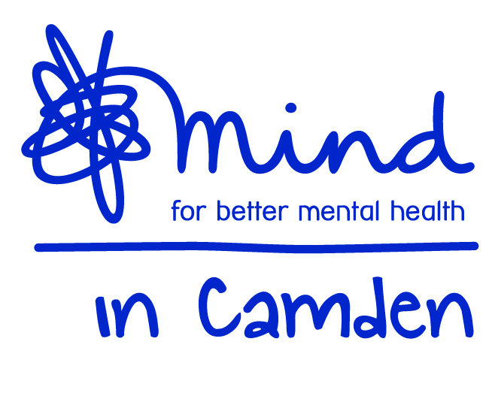

Mind in Camden

Female Sylheti Mental Health Development Worker
21 hours per week
Temporary post to April 2018 (with possible extension)

Job Description

Job title: Female Sylheti Mental Health Development Worker
Accountable to: Senior Link Worker
Accountable for: Sessional Gardener and Volunteers
Grade: SCP 18-21: starting at SCP 18: £22,227 pa part time including ILW (pro rata): £13,336 pa for 21 hours

Aims of the Job:

- Ensure the Social Prescribing offer of the TAP service is well promoted and understood in the Bangladeshi Community
- Ensure Bangladeshi women have a supported Social Prescribing service available as part of the TAP service through developing a community group based around a Horticulture theme at Kentish Town City Farm. Ensure this group is developed alongside a generic Horticulture group and opportunities for expanding the impact of these is fully explored and implemented.
- Set up workshops/groups and resources within GP surgeries to enable people from the Bangladeshi community to find out about and connect with support in their community for their mental health.

Horticultural Group Work
- To organise, promote and facilitate Horticulture groups at Kentish Town City Farm for Sylheti speaking women.
- Organise, promote and facilitate a generic community Horticulture group at Kentish Town City Farm.
- Ensure all groups are structured so all participants are able to contribute to discussions, planning and have an opportunity to be involved in the gardening work on a variety of levels.
- Ensure all group participants are assessed and receive a health and safety induction.
- Ensure the groups abide within the terms and conditions of the contractual arrangement between Mind in Camden and Kentish Town City Farm.
- Oversee the development of these groups and explore ways to expand their impact through a Co-produced approach.
- Ensure the impact of the groups to individuals and the wider community is assessed and reported on as required.
- Supervise and support a sessional gardener to enable them to assist and use their skills to enhance the groups and the learning of individual participants.

Development Work
- Liaise with GP surgeries in Camden to explore the opportunity to set up groups/workshops and resource spaces for the Bangladeshi community with GP spaces.
- Deliver workshops/groups and set up resource spaces within surgeries.
- Provide talks to GPs on working with the Bangladeshi community and help with their education on the resources available in the community to support the mental health of Camden’s Bangladeshi population.

Team and Partnership Responsibilities
- Participate in ensuring that an up-to-date information resource on services in Camden is available for clients, GPs and the wider TAP team.
- Work alongside others in the TAP service to ensure better access to the TAP service for the Bangladeshi Community, through effective promotion and engagement with Bangladeshi services in Camden.
- Work collaboratively with Tavistock and Portman NHS Staff and GPs to support the smooth and integrated running of the TAP service.
- Ensure the gathering and inputting of accurate information on client outputs and outcomes of those worked with.
- Ensure a committed working towards activity and performance targets set by your Manager.
- Assist your Manager in inducting, supporting and coaching volunteers.

General Duties:
- Work within the context of the wider Mind in Camden organisation and participate in internal and external meetings as required.
- Work alongside partner staff as an integrated team and participate in related internal and external meetings as required by your Manager.
- Work to Mind in Camden policies, procedures and guidance.
- Work in accordance with TAP policies procedures, plans and guidance.
- Be accountable for all aspects of your work to your line manager through supervision.
- Undergo such training and qualification as is consistent with the satisfactory performance in the post.
- Perform other duties as reasonably required by your line manager.

All staff are expected to:
  - Recognise changes in circumstances promptly and adjust plans and activities accordingly.
  - Find practical ways to overcome barriers.
  - Present information clearly, concisely, accurately and in ways that promote understanding.
  - Assist in creating a sense of common purpose.
  - Make best use of available resources and proactively seek new sources of support when necessary.
  - Act within the limits of their own authority.
  - Be vigilant for potential risks and hazards.
  - Take pride in delivering high quality work.
  - Take personal responsibility for making things happen.
  - Take personal responsibility for effectively communicating with service users, members of their work team, managers and other work groups.
  - Consult with their work group about matters which directly affect their work.
  - Deal with service user complaints.

Main Conditions of Service:
- The post is subject to maintaining an Honorary Contract with the Tavistock and Portman HNS Trust
- Overtime is not paid, but time off in lieu may be granted.
- The salary scale is SCP 18-21: starting at SCP 18: £22,227 pa part time including ILW (pro rata): £13,336 pa for 21 hours
- The post is currently funded to April 2018 but may be extended.
- Mind in Camden has an auto-enrolled pension scheme into which it currently pays 5% of salary. From 2019 you will be required to contribute an additional 3% into the scheme

- The hours of work are 21 per week that will be worked between 9.30am – 5.30pm with a one hour (unpaid) lunch break. Evening, weekend and bank holiday work may be required on occasion. The weekly agreed hours will need to include Mondays and Tuesday PM. There is some flexibility on other days and times.
- Annual leave entitlement is initially 27 days plus public holidays (pro-rata for part-time staff).
- All Mind in Camden job descriptions may be subject to periodic review.
- The post holder will work across multiple sites in Camden.

Mind in Camden

Sylheti Mental Health Link Worker & Horticultural Group Development Worker

Person Specification

All areas in the person specification are essential unless stated otherwise

Qualifications
- A mental health related qualification (desirable).

Knowledge
- A good broad understanding of mental health issues.
- A good awareness of different models of understanding of mental health
- A good awareness of current issues in policy and practice in mental health.
- A good understanding of primary, secondary care and third sector mental health services.
- Thorough understanding of co-production and recovery principles.
- Thorough understanding of the principles of good customer service.
- Thorough understanding of good practice in person-centred client work and in group work.
- Thorough understanding of cultural understanding of mental health and in particular barriers facing the Sylheti speaking community in accessing support.
- Thorough understanding of equal opportunities with particular emphasis on how it applies to users of mental health services.
- An understanding of the principles of good partnership working.
11. An understanding of how to build and develop successful small projects or groups.
12. An understanding of how to develop culturally sensitive services.
13. A basic knowledge and understanding of gardening or horticulture.

Experience
- Experience of 1:1 client work.
- Experience of organising and facilitating groups.
- Experience of community development work or similar.
- Experience of partnership work.
- At least two years of working or volunteering in mental health services.
- Experience of working alongside or supervising volunteers (desirable)
- Experience of gardening or similar.

Skills & Abilities
- Strong communication and interpersonal skills.
- Strong motivational and influencing skills.
- Bilingual: able to speak fluent English and Sylheti.
- An ability to facilitate groups.
- An ability to develop small projects or groups.
- An ability to participate in physical gardening work alongside service users.
- Ability to take responsibility for key clients.
- Ability to produce written materials to a high standard, including assessments and minutes of meetings.
- Ability to communicate constructively and professionally with service users, staff, colleagues and external agencies.
- Ability to plan and prioritise your own workload.
- Ability to work flexibly and cooperatively, balancing multiple responsibilities.
- Ability to handle formal and informal disputes and complaints constructively.
- Good level of computer skills with knowledge of Word and Excel.
- Ability to manage your own stress in a busy and demanding environment.
- Ability to work independently and to utilise support effectively.
- Ability to work at evenings and weekends, sometimes at short notice

Commitment to:
- Implementation of equal opportunities through anti-discriminatory practice.
- Strengths-based recovery approach to client work and person centred practice.
- Confidentiality.
- Accountability for your work to your manager.

