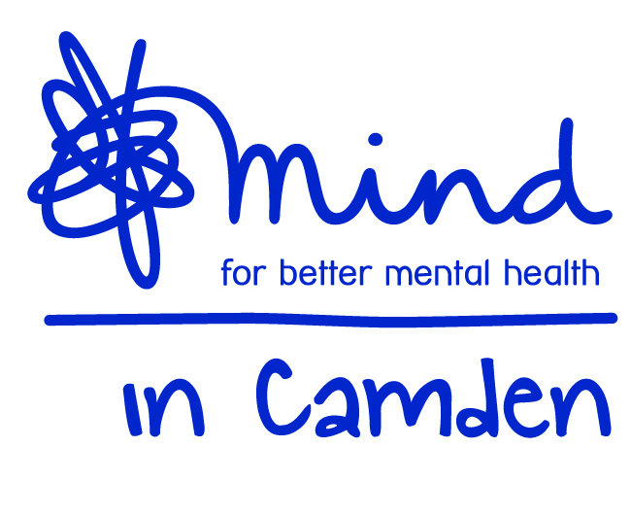

Mind in Camden

TAP Social Prescribing Senior Mental Health Link Worker
(Full Time 35 hours per week)

Temporary post to April 2018 (with possible extension)

Job Description

Job title TAP Social Prescribing Senior Mental Health Link Worker
Accountable to Operations Director
Responsible for: Link Worker Staff (currently three staff)
Grade NJC SCP 26-28 starting at SCP 26 starting at £27,555 including ILW.

Aim of the Job:
- To take responsibility for the management and development of the Social Prescribing element of the TAP service.
- To ensure clients referred to the TAP service are supported to access Camden based community services to assist with their mental health recovery.
- To ensure project staff and volunteers, are working within professional and personal boundaries to provide high quality services to service users.
- To ensure the Link Worker Team contributes effectively and professionally to the overall TAP service, to maintain focus on the overall service outcomes.
- To take responsibility for ensuring the effective implementation of development activities within the Social Prescribing Team, including a Horticultural Project and specific groups for the Bangladeshi Community.

.Management Responsibilities
  - Effectively recruit, induct, supervise, support, coach and appraise the performance of project staff.
  - Ensure that appropriate and accurate records of the work are maintained.
  - Lead on the production and regular review of plans, policies, procedures and guidelines for the project.
  - Ensure the Link Worker Team works to Plans, Policies and Procedures agreed with the Tavistock and Portman NHS Trust.
  - Ensure the Link Worker Team works proactively to achieve activity and performance targets and effectively review and address any under performance.
  - Ensure consultation with staff and service users as appropriate.
  - Take responsibility for monitoring and controlling spending in line with agreed budgets.
  - Facilitate regular and effective team and stakeholder meetings.
  - Contribute to ensuring that service users have influence over the delivery and management of the services within TAP
  - Ensure effective liaison with outside agencies and with other Mind in Camden services.
  - Ensure that all work is carried out according to Mind in Camden policies and procedures.
  - Produce reports to committee, funders and other stakeholders according to specification

Direct Work with Service users
  - Support clients to assess their needs in line with the established assessment framework.
  - Support clients to understand the range of options available to them.
  - Ensure clients are supported to make choices and access the services identified.
  - Oversee a case load of specific clients, and act as a contact for these clients’ related professionals and members of the clients’ support networks in accordance with clients’ consent data protection policies
  - Document client work and ensure that it is recorded on appropriate paper and electronic records.
  - Respond to crisis, safeguarding issues and complaints effectively.

Team and Partnership Responsibilities
- Ensure an up-to-date information resource on services in Camden is available for clients. GPs and the wider TAP team.
- Work collaboratively with Tavistock and Portman NHS Staff and GPs to support the smooth and integrated running of the TAP service.
- Ensure the gathering and inputting of accurate information on client outputs and outcomes of those worked with by the Link Worker Team.
- Participate in TAP service meetings as required.
- Prepare monitoring reports in accordance with established reporting frameworks

General Duties:
- Work within the context of the wider Mind in Camden organisation and participate in internal and external meetings as required.
- Work alongside partner staff as an integrated team and participate in related internal and external meetings as required by your Manager.
- Work to Mind in Camden policies, procedures and guidance.
- Work in accordance with TAP policies procedures and guidance.
- Be accountable for all aspects of your work to your line manager through supervision.
- Undergo such training and qualification as is consistent with the satisfactory performance in the post.
- Perform other duties as reasonably required by your line manager.

All staff are expected to:
  - Recognise changes in circumstances promptly and adjust plans and activities accordingly.
  - Find practical ways to overcome barriers.
  - Present information clearly, concisely, accurately and in ways that promote understanding.
  - Assist in creating a sense of common purpose.
  - Make best use of available resources and proactively seek new sources of support when necessary.
  - Act within the limits of their own authority.
  - Be vigilant for potential risks and hazards.
  - Take pride in delivering high quality work.
  - Take personal responsibility for making things happen.
  - Take personal responsibility for effectively communicating with service users, members of their work team, managers and other work groups.
  - Consult with their work group about matters which directly affect their work.
  - Deal with service user complaints.

Main Conditions of Service:
- The post is subject to maintaining an Honorary Contract with the Tavistock and Portman HNS Trust
- Salary scale is NJC SCP 26-28 starting at £27,555 including Inner London Weighting. Overtime is not paid, but time off in lieu may be granted.
- The post is currently funded until April 2018 but may be extended.
- Mind in Camden has an auto-enrolled pension scheme into which it currently pays 5% of salary. From 2019 employees will be required to contribute an additional 3% into the scheme
- The hours of work per week are 35 that will be worked between 9.30am – 5.30pm with a one hour (unpaid) lunch break. Evening, weekend and bank holiday work may be required on occasion.
- Annual leave entitlement is initially 27 days plus public holidays.
- All Mind in Camden job descriptions may be subject to periodic review.
- The post holder will work across multiple sites in Camden.

Mind in Camden

TAP Social Prescribing Senior Mental Health Link Worker

Person Specification

All areas in the person specification are essential unless stated otherwise

Qualifications
- A mental health related qualification (desirable).
- Ongoing attendance at continued professional development courses in mental health.

Knowledge
- An excellent understanding of mental health issues from a range of perspectives.
- A good awareness of current issues in policy and practice in mental health.
- A good understanding of primary, secondary care and third sector mental health services.
- Thorough understanding of co-production and recovery principles.
- Thorough understanding of the principles of good customer service.
- Thorough understanding of good practice in person-centred client work.
- Thorough understanding of equal opportunities with particular emphasis on how it applies to users of mental health services.
- An understanding of the principles of good partnership working.

Experience
- Experience as a Manager or Senior Worker within mental health or a related field
- Minimum of 3 years of working in mental health services, in a paid or unpaid capacity
- Experience of managing and supervising staff or volunteers
- Experience of partnership working.
- Experience of community development work or similar (desirable)
- Experience of 1:1 client work.

Skills & Abilities
- Strong communication and interpersonal skills.
- Ability to effectively recruit, induct, supervise, appraise, coach and line manage individual staff and volunteers
- Strong organisational awareness.
- Ability to lead and motivate a team to meet service targets.
- Ability to manage and control budgets and expenditure.
- Ability to take responsibility for key clients.
- Ability to produce written materials to a high standard, including assessments, minutes of meetings and reports.
- Ability to communicate constructively and professionally with service users, staff, colleagues and external agencies.
- Ability to plan and prioritise your own workload.
- Ability to work flexibly and cooperatively, balancing multiple responsibilities.
- Ability to handle formal and informal disputes and complaints constructively.
- Good level of computer skills.
- Ability to manage your own stress in a busy and demanding environment.
- Ability to work independently and to utilise support effectively.

Commitment to:
- Implementation of equal opportunities through anti-discriminatory practice.
- Strengths-based recovery approach to client work and person centred practice.
- Confidentiality.
- Accountability for your work to your manager.

