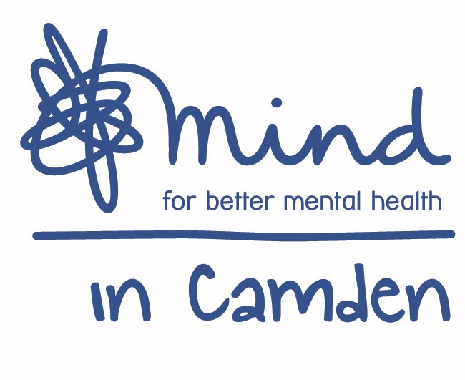

Mind in Camden

Parent and Carer Link Worker
Tavistock Outreach in Primary Schools with Families Project (TWF)
(10.5 hrs per week for 12 months with possible extension)

Job title: Parent and Carer Link Worker
(Tavistock Outreach in Primary Schools with Families Project)
Accountable to: Operations Director
Grade: NJC SCP 14 -17, starting at SCP 14
Hours: 10.5 hrs per week
Aim of the Job: To support parents/carers and adult family members referred through the Tavistock Outreach in Primary Schools With Families Project (TWF) to access Camden based community services to assist with their mental health and family wellbeing

Direct Work with Service Users
  - Support clients to assess their needs in line with the established assessment framework.
  - Support clients to understand the range of options available to them.
  - Ensure clients are supported to make choices and access the services identified.
  - Oversee a caseload of specific clients as directed by your Manager, and act as a contact for these clients’ related professionals and members of the clients’ network of support in accordance with clients’ consent data protection policies.
  - Document client work and ensure that it is recorded on appropriate paper and electronic records.
  - Respond to crises, safeguarding issues (concerning adults and/or children) and complaints in a timely and effective manner, following TWF and MiC policies.

Team and Partnership Responsibilities
- Participate in ensuring an up-to-date information resource on services in Camden is available for clients and the wider TWF team.
- Provide support, consultation and training to school staff, who will work directly with certain families referred to TWF.
- Work collaboratively with Tavistock and Portman TWF Staff to support the smooth and integrated running of the TWF service, including attendance at TWF fortnightly team meetings on Wednesdays.
- Ensure the gathering and inputting of accurate information on client outputs and outcomes of those worked with.
- Ensure committed working towards activity and performance targets set by your Manager.

General Duties:
- Work within the context of the wider Mind in Camden organisation and participate in internal and external meetings as required.
- Work alongside partner staff as an integrated team and participate in related internal and external meetings as required by your Manager.
- Work to Mind in Camden policies, procedures and guidance.
- Work in accordance with TWF policies procedures, plans and guidance.
- Be accountable for all aspects of your work to your line manager through supervision.
- Undergo such training and qualification as is consistent with the satisfactory performance in the post.
- Perform other duties as reasonably required by your line manager.

All staff are expected to:
  - Recognise changes in circumstances promptly and adjust plans and activities accordingly.
  - Find practical ways to overcome barriers.
  - Present information clearly, concisely, accurately and in ways that promote understanding.
  - Assist in creating a sense of common purpose.
  - Make best use of available resources and proactively seek new sources of support when necessary.
  - Act within the limits of their own authority.
  - Be vigilant for potential risks and hazards.
  - Take pride in delivering high quality work.
  - Take personal responsibility for making things happen.
  - Take personal responsibility for effectively communicating with service users, members of their work team, managers and other work groups.
  - Consult with their work group about matters which directly affect their work.
  - Deal with service user complaints.

Main Conditions of Service:
- The salary is within the NJC grade14-17 starting at scale point 14 which is £6,551 for 10.5 hours per week (pro rata of £21,838). There is an NJC pay award pending from April 2019.
- The post is funded for 12 months with a possible extension.
- The post is dependent on maintaining an Honorary Contract with the Tavistock and Portman NHS Trust
- Overtime is not paid, but time off in lieu may be granted.
- Mind in Camden has an auto-enrolled pension scheme into which it contributes 5% of salary. From 1st April 2019 staff will be required to contribute an additional 3% into the scheme.
- The hours of work are 10.5 per week worked over 2 days per week between 9.30am – 5.30pm with a one hour (unpaid) lunch break. Evening, weekend and bank holiday work may be required on occasion.
- Annual leave entitlement is initially 27 days plus public holidays (pro rata for part-time staff) Please note: annual leave will need to be taken within specific time frames (e.g. when schools are not open)
- All Mind in Camden job descriptions may be subject to periodic review.
- The post holder will work across multiple sites in Camden and the Tavistock clinic.

Mind in Camden

Parent and Carer Link Worker
Tavistock Outreach in Primary Schools with Families Project (TWF)

Person Specification

All areas in the person specification are essential unless stated otherwise

Qualifications
- None specifically required, but evidence of mental health learning essential (e.g. CPD courses, counselling/therapeutic study, community mental health study or relevant degree)

Knowledge
- A good broad understanding of mental health issues.
- A good awareness of different models of understanding of mental health
- A good awareness of current issues in policy and practice in mental health.
- A good understanding of primary, secondary care and third sector mental health services.
- Thorough understanding of co-production and recovery principles.
- Thorough understanding of the principles of good customer service.
- Thorough understanding of good practice in person-centred client work.
- Thorough understanding of equal opportunities with particular emphasis on how it applies to users of mental health services.
- An understanding of the principles of good partnership working.

Experience
- Experience of 1:1 client work.
- One year or more experience of working or volunteering in mental health services.
- Experience of community work (desirable)

Skills & Abilities
- Strong communication and interpersonal skills.
- Ability to take responsibility for key clients.
- Ability to produce written materials to a high standard, including assessments and client letters.
- Ability to communicate constructively and professionally with service users, staff, colleagues and external agencies.
- Ability to plan and prioritise your own workload.
- Ability to work flexibly and cooperatively, balancing multiple responsibilities.
- Ability to handle formal and informal disputes and complaints constructively.
- Good level of computer skills, including ability to use a database.
- Ability to manage your own stress in a busy and demanding environment.
- Ability to work independently and to utilise support effectively.

Commitment to:
- Implementation of equal opportunities through anti-discriminatory practice.
- Strengths-based recovery approach to client work and person centred practice.
- Confidentiality.
- Accountability for your work to your manager.

