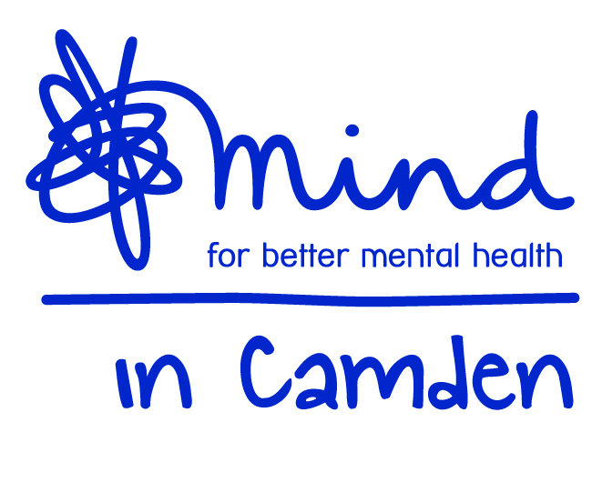

Mind in Camden

Mental Health Link Worker
(25.5 hours per week)
The post is funded until 31st March 2020 with probable extension

Job title: Mental Health Link Worker
Accountable to Senior Link Worker
Grade: NJC SCP 5-6, starting at SCP 5: £16,722 (pro rata of £22,952 FTE) Inc. ILWA
Hours 25.5 hours per week (part-time)
Aim of the Job: To support clients referred by GPs to the TAP service to access Camden based community services to assist with their mental health recovery.

Direct Work with Service users
  - Support clients to assess their needs in line with the established assessment framework.
  - Support clients to understand the range of options available to them.
  - Ensure clients are supported to make choices and access the services identified.
  - Oversee a case load of specific clients as directed by your Manager, and act as a contact for these clients’ related professionals and members of each client’s network of support in accordance with data protection policies
  - Document client work and ensure that it is recorded appropriately on paper and electronic records.
  - Respond to crises, safeguarding issues and complaints effectively.

Team and Partnership Responsibilities
- Participate in ensuring an up-to-date information resource on services in Camden is available for clients. GPs and the wider TAP team.
- Work collaboratively with Tavistock and Portman NHS staff and GPs to support the smooth and integrated running of the TAP service.
- Ensure the gathering and inputting of accurate information on client outputs and outcomes. Ensure committed working towards activity and performance targets set by your Manager.
- Assist your Manager in inducting, supporting and coaching volunteers if required.

General Duties:
- Work within the context of the wider Mind in Camden organisation and participate in internal and external meetings as required.
- Work alongside partner staff as an integrated team and participate in related internal and external meetings as required by your Manager.
- Work to Mind in Camden policies, procedures and guidance.
- Work in accordance with TAP policies procedures, plans and guidance.
- Be accountable for all aspects of your work to your line manager through supervision.
- Undergo such training and qualification as is consistent with the satisfactory performance in the post.
- Perform other duties as reasonably required by your line manager.

All staff are expected to:
  - Recognise changes in circumstances promptly and adjust plans and activities accordingly.
  - Find practical ways to overcome barriers.
  - Present information clearly, concisely, accurately and in ways that promote understanding.
  - Assist in creating a sense of common purpose.
  - Make best use of available resources and proactively seek new sources of support when necessary.
  - Act within the limits of their own authority.
  - Be vigilant for potential risks and hazards.
  - Take pride in delivering high quality work.
  - Take personal responsibility for making things happen.
  - Take personal responsibility for effectively communicating with service users, members of their work team, managers and other work groups.
  - Consult with their work group about matters which directly affect their work.
  - Deal with service user complaints.

Main Conditions of Service:
- Salary scale is NJC SCP 5–6 starting at SCP 5: £16,722 (pro rata of £22,952 FTE) inc. ILWA
- Overtime is not paid, but time off in lieu may be granted.
- Mind in Camden has an auto-enrolled pension scheme into which it currently pays 5% of salary and staff will be required to contribute an additional 3%.
- The hours of work per week are 25.5 worked between 9.30am – 5.30pm with a one hour (unpaid) lunch break. Evening, weekend and bank holiday work maybe be required on occasion.
- Annual leave entitlement is a pro rata amount of 27 days plus bank holidays.
- All Mind in Camden job descriptions may be subject to periodic review.
- The post holder will work across multiple sites in Camden.

Mind in Camden

Mental Health Link Worker

Person Specification

All areas in the person specification are essential unless stated otherwise

Qualifications
- None specifically required, but evidence of mental health learning essential (e.g. CPD courses, counselling/therapeutic study, community mental health study or relevant degree)

Knowledge
- A good broad understanding of mental health issues.
- A good awareness of different models of understanding of mental health
- A good awareness of current issues in policy and practice in mental health.
- A good understanding of primary, secondary care and third sector mental health services.
- Thorough understanding of co-production and recovery principles.
- Thorough understanding of the principles of good customer service.
- Thorough understanding of good practice in person-centred client work.
- Thorough understanding of equal opportunities with particular emphasis on how it applies to users of mental health services.
- An understanding of the principles of good partnership working.

Experience
- Experience of 1:1 client work.
- One year or more experience of working or volunteering in mental health services.
- Experience of community work (desirable)

Skills & Abilities
- Strong communication and interpersonal skills.
- Ability to take responsibility for key clients.
- Ability to produce written materials to a high standard, including assessments and client letters.
- Ability to communicate constructively and professionally with service users, staff, colleagues and external agencies.
- Ability to plan and prioritise your own workload.
- Ability to work flexibly and cooperatively, balancing multiple responsibilities.
- Ability to handle formal and informal disputes and complaints constructively.
- Good level of computer skills, including ability to use a database.
- Ability to manage your own stress in a busy and demanding environment.
- Ability to work independently and to utilise support effectively.

Commitment to:
- Implementation of equal opportunities through anti-discriminatory practice.
- Strengths-based recovery approach to client work and person centred practice.
- Confidentiality.
- Accountability for your work to your manager.

