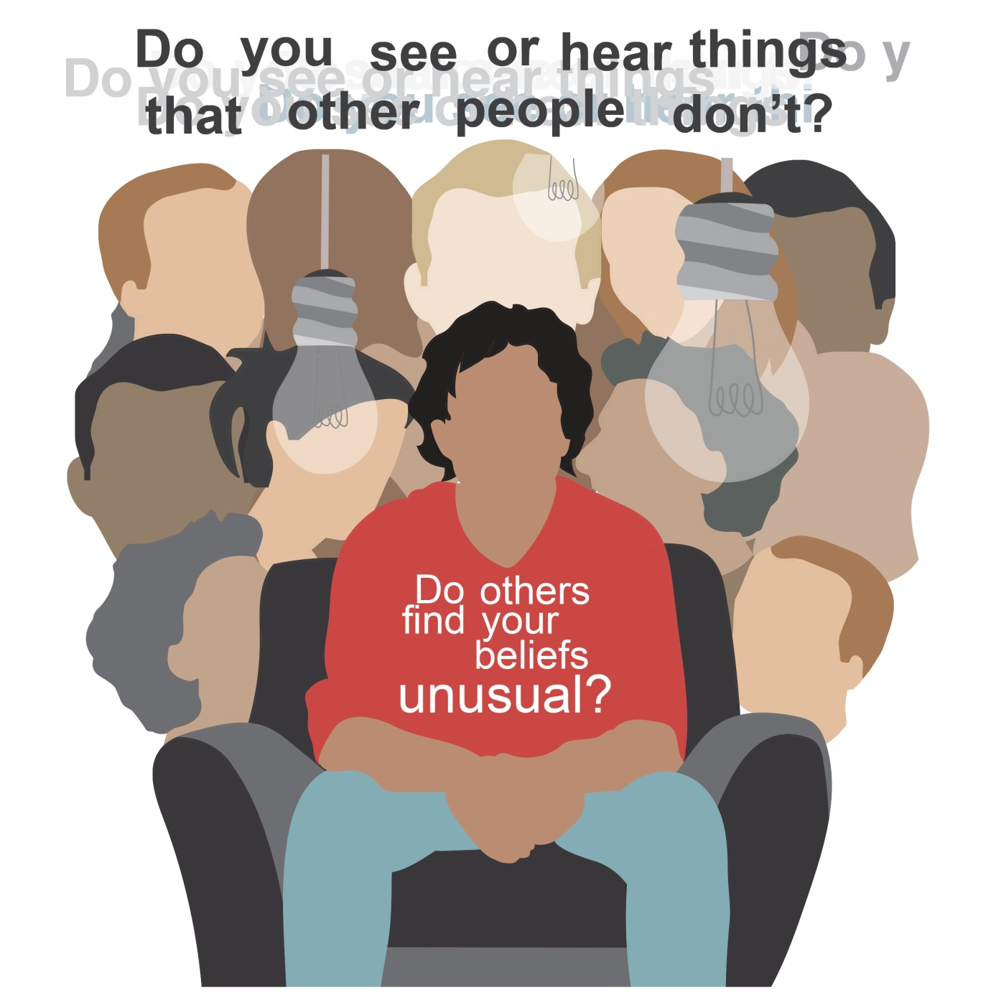

What’s it about?
We meet once a week. It is a safe space to talk freely and openly about your beliefs and experiences, both positive and distressing.
Anyone can take part in the group
There will be two people facilitating the group, however everybody is equal and no one is there to judge you.
We do not have all the answers, we just believe sharing your experiences can help you and others.
So come along and help create a supportive environment for you and your peers.
If you want to talk to someone about the group further, please contact Rachel at Rachel.yates@mungos.org or 07786 855372

Unusual Beliefs Group
When: Every Wednesday 11-12pm
Where:
Haminados café, 78 Chepstow Rd, London W2 5BE

