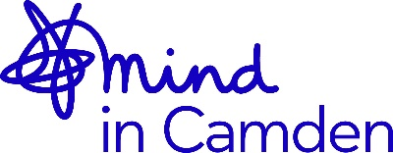

Mind in Camden
Equality Monitoring Form - Recruitment
Senior Community Mental Health Recovery Support Worker 2021

Date completed:
We want Mind in Camden to be an open and welcoming organisation. Equality monitoring is one way to get a picture of the people who are interested to be with us. We use the data you provide to identify improvements that we turn into an annual action plan. The more people who participate, the more accurate that picture is so we do really value your help. Forms are dealt with anonymously and destroyed once monitored. Please tick the responses which you feel best describe your circumstances.

1. How do you describe your gender
or do you prefer not to say? _____________________________________________

2. How would you define your ethnicity?

Asian Black White Mixed Race
- British - British - British (please state)
- Bangladeshi - African - Irish
- Indian - Caribbean - European
- Pakistani - African/Caribbean - non-European
- Sri Lankan
- SE Asian

None of the above; I define my ethnicity as: _________________________________________
I prefer not to say

3. Do you perceive yourself to have, or have had, a disability?

Yes No I prefer not to say

4. Do you have experience of mental distress and/or have used mental health services?

Yes No I prefer not to say

5. Your age group:

16-21 22-35 36-45 46-55 56-65 66 or over I prefer not to say

6. How do you describe your sexuality
or do you prefer not to say? ______________________________________________

7. Do have a religious or other belief?
No
Yes (please state) _____________________________________________
I prefer not to say

8.Where did you hear about this vacancy? ___________________________________________

Thank you for completing this form

